Deploy Infrastructure
Initialize: terraform init
Validate: terraform validate
Format: terraform fmt
Plan: terraform plan
Deploy: terraform apply
Type: yes

PS C:\Users\admin\Desktop\Terraform-3tier-Project> terraform init
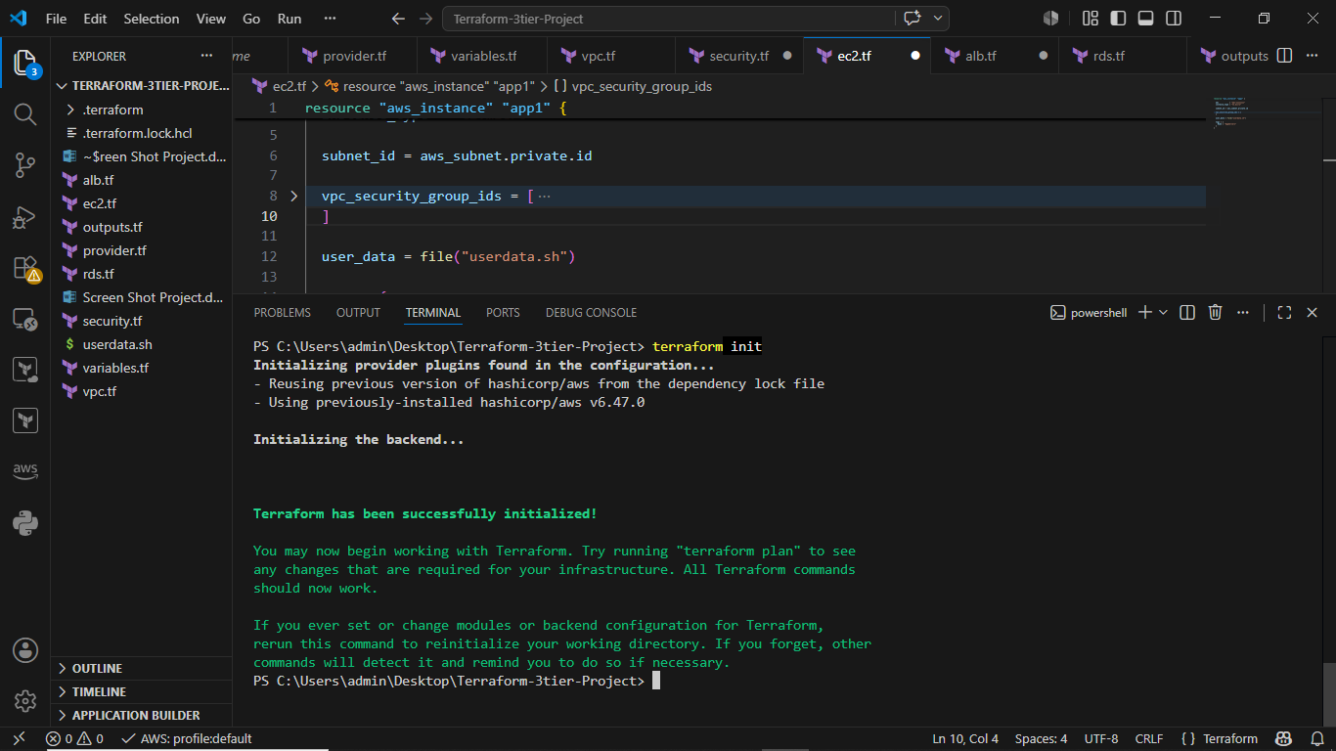
PS C:\Users\admin\Desktop\Terraform-3tier-Project> terraform validate
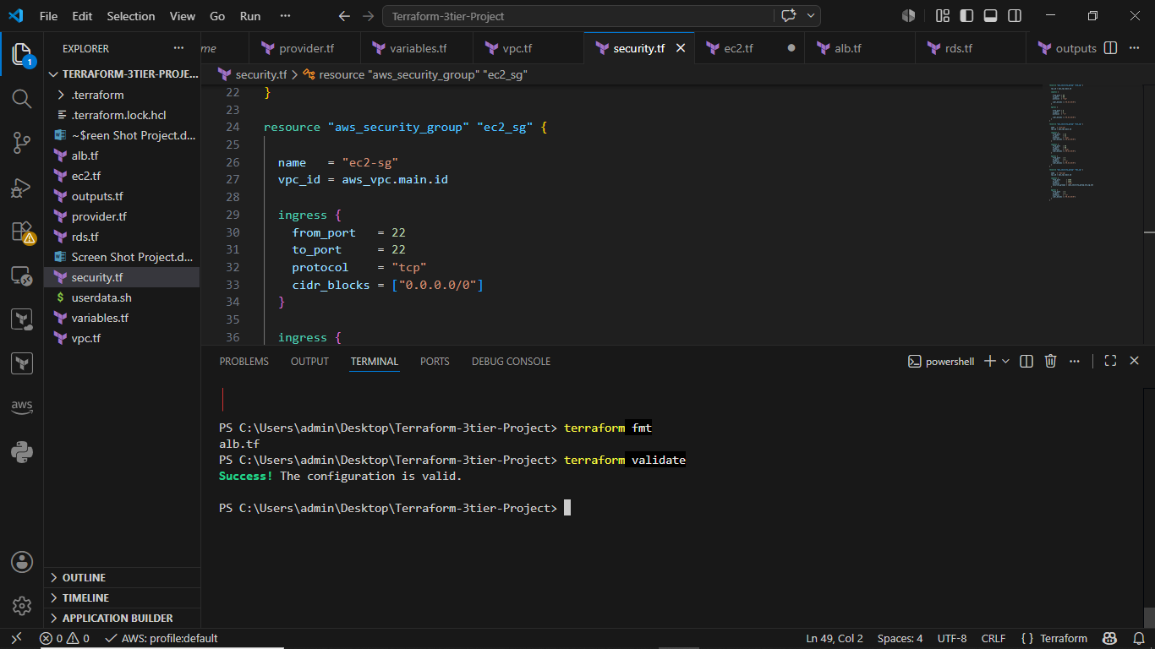

PS C:\Users\admin\Desktop\Terraform-3tier-Project> terraform plan

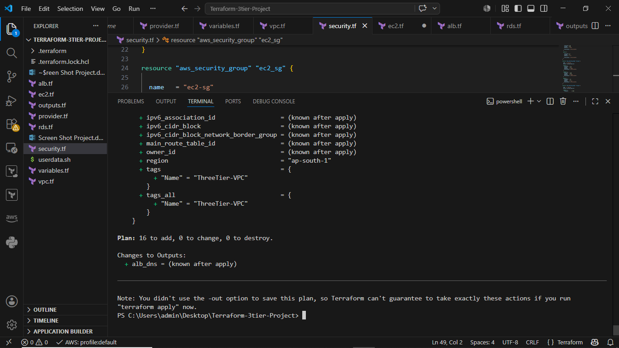

PS C:\Users\admin\Desktop\Terraform-3tier-Project> terraform apply

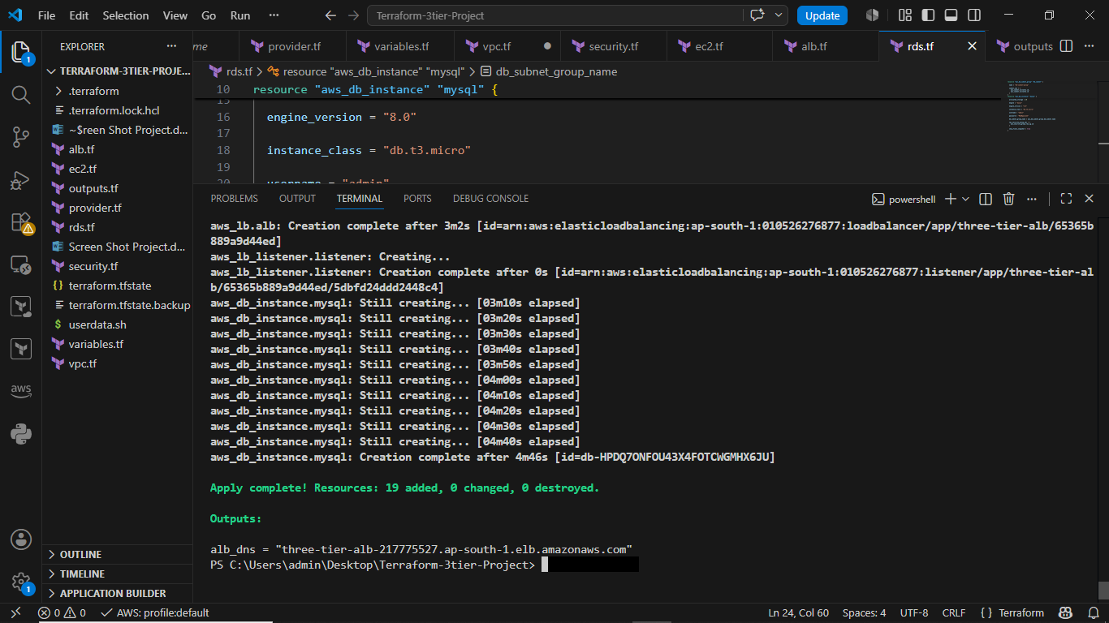

Expected Final Architecture
Internet
|
Application Load Balancer
|
-------------------------
| |
EC2-App1 EC2-App2
Private-1 Private-2
| |
-------- MySQL RDS -------
Multi-AZ
Public-1 Public-2
AZ-1a AZ-1b
Private-1 Private-2
AZ-1a AZ-1b
VPC 10.0.0.0/16

Next Step: Verification
Check: VPC: AWS Console → VPC
Verify:
VPC Created
Subnets Created
IGW Attached

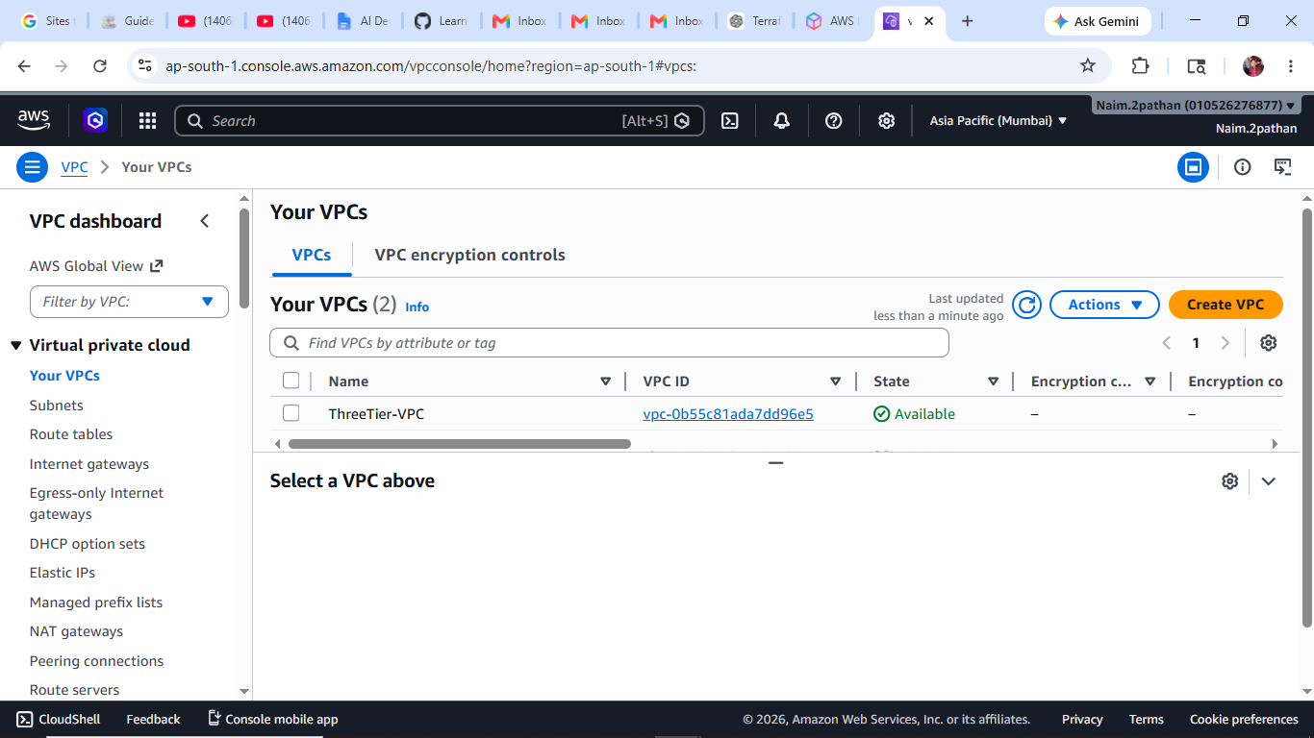

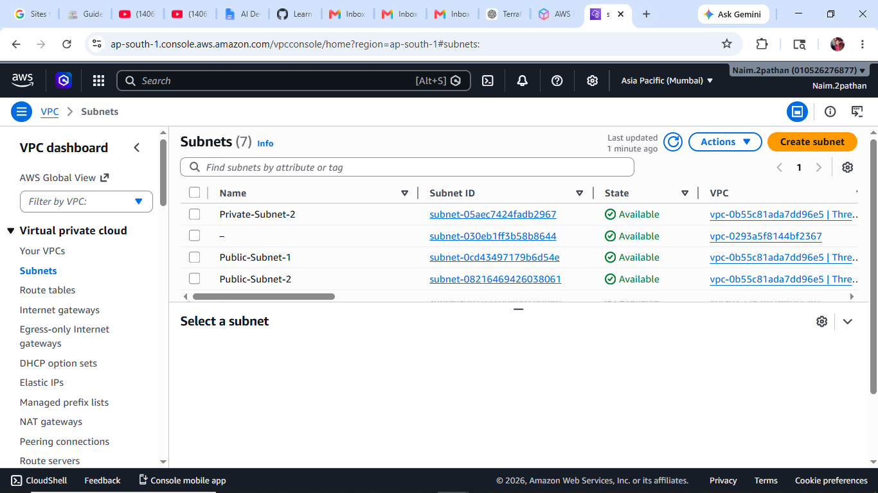

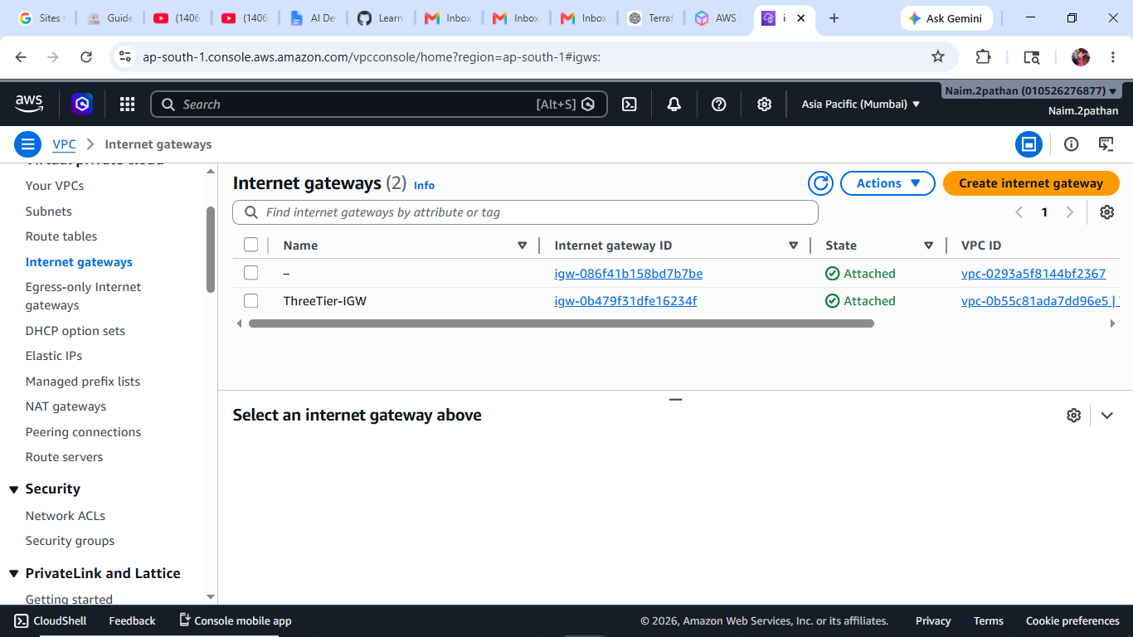

EC2
AWS Console → EC2
Verify:
2 Instances Running
Apache Installed

ALB
Get DNS: terraform output
Example: alb_dns = "three-tier-alb-217775527.ap-south-1.elb.amazonaws.com
Open browser: http:// three-tier-alb-217775527.ap-south-1.elb.amazonaws.com
Expected: Welcome to Three Tier App

RDS
Check: RDS Status = Available
Connect from EC2: mysql -h endpoint -u admin -p

Last Step : Destroy Infrastructure
Very Important: terraform destroy
Confirm: yes

